Title of the Project: Large Language Models for Graph-Based Fraud Detection
Supervisor: Dr. Venus Haghighi
Unit: COMP8851
Project Team Members: Prajan Bhattarai [OneID], Mustafa Ugur Atas [OneID], Zeki Kose [OneID], Abhishek Biswal [OneID]
[Team: replace [OneID] placeholders with each member's actual OneID before submission.]
Introduction
Fraud in digital financial systems is a large and growing problem: illicit activity in domains such as credit-card payments, e-commerce, and cryptocurrency transfers costs businesses and consumers billions of dollars annually, and undetected fraud damages user trust as much as it damages balance sheets. Because fraud is inherently relational — illicit actors move funds through chains of accounts, shared devices, or coordinated transfers — a large body of recent research models these interactions as graphs and applies Graph Neural Networks (GNNs) to detect structural patterns that record-level classifiers cannot see. GNNs, however, mostly reason over numerical or categorical features and struggle to exploit the richer contextual signal that free-text or semi-structured transaction metadata can provide. Large Language Models (LLMs) are a natural complement: they can encode contextual and semantic information, and, in principle, help models adapt to fraud patterns that are novel or under-labelled.
This project, undertaken for COMP8851, builds and evaluates a working prototype that compares graph-only, text/LLM-only, and fused graph+text approaches to fraud detection, using the Elliptic Bitcoin transaction dataset as a public, reproducible benchmark. Concretely, the project trains and evaluates seven models on an identical chronological train/validation/test split: two classical baselines (Logistic Regression, Random Forest) that see only per-node transaction features; three GNN architectures (GCN, GraphSAGE, GAT) that see only the transaction graph; and two graph+text fusion models that combine GraphSAGE's learned node embeddings with text embeddings of a synthesised natural-language profile of each node, encoded first with a lightweight sentence encoder and then with a larger LLM (LLaMA-3.2-1B-Instruct). All seven results are produced by an executable, reproducible pipeline in this project's repository, not by hand-picked figures.
It matters that this report say so plainly: the project's scope and methodology have both changed since Assessment 1. The original proposal targeted the IEEE-CIS Fraud Detection dataset with a TAPE-style pipeline in which an LLM generates a per-transaction natural-language explanation used as a classification feature. What has actually been implemented and executed is a pipeline built around the Elliptic dataset, using embedding-based text fusion rather than per-node LLM explanation generation. Section 3 (Research Methodology) presents this revised plan as it now stands, and Section 4 (Research Progress) explains, sub-problem by sub-problem, why the change was made, what it cost the project, and which parts of the original plan remain open. At the time of writing, the full comparative pipeline runs end-to-end and produces the results discussed below; what remains outstanding is primarily the explainability and generalisation-focused work that the original TAPE-style and FLAG-style components were meant to provide.
In brief, the headline finding so far is not flattering to the project's central hypothesis: a plain Random Forest baseline currently outperforms every graph-based and fusion model on precision, F1, and PR-AUC. Text fusion does, however, produce a clear and consistent improvement over the GraphSAGE-only model, and the improvement grows substantially when the larger LLaMA encoder is used in place of the lightweight sentence encoder. This mixed result , real progress on one axis, a still-open gap on another , is treated as the substantive finding of this stage of the project rather than a result to be smoothed over, and it directly shapes the remaining work described in Section 6.
Literature Review
Early financial fraud detection systems relied on hand written rules, and these gave way to classical machine learning as labelled transaction data became easier to collect, before the field turned to deep learning and, more recently, to models that treat transactions as a graph. Ali et al. (2022) give a sense of where the classical era settled: across the 93 machine learning fraud studies they reviewed, Support Vector Machines and Artificial Neural Networks appeared more often than any other algorithm, and credit card fraud was the scenario researchers chose most. Subsequent work explored deep sequential and convolutional architectures: Alghofaili et al. (2020) showed LSTM-based models could outperform autoencoders on credit-card fraud data, and Chen and Lai (2021) demonstrated a deep convolutional approach with strong real-time performance on a similar task.

These approaches share a common limitation: they treat transactions as independent, tabular records, and so cannot capture the relational patterns — shared accounts, coordinated timing, clustered behaviour — that characterise much real-world fraud. This motivated a shift toward graph-based methods. Motie and Raahemi's (2024) systematic review of GNN-based financial fraud detection shows how modelling transactions and accounts as graphs lets models exploit connectivity patterns invisible to record-level classifiers. The Elliptic dataset used in this project is itself central to this literature: Weber et al. (2019) introduced it alongside the first systematic comparison of classical and graph-based classifiers for anti-money-laundering, and — notably for the results reported in Section 4 of this report — found that a Random Forest baseline trained on Elliptic's engineered node features outperformed their Graph Convolutional Network baseline on illicit-class F1, a result this project's own experiments independently reproduce six years later with a different GNN implementation. Architecturally, this project's three GNN encoders build directly on Kipf and Welling's (2017) Graph Convolutional Network, Hamilton et al.'s (2017) GraphSAGE, and Veličković et al.'s (2018) Graph Attention Network — chosen so that any weakness observed is attributable to the GNN paradigm on this dataset in general, rather than to one architecture's idiosyncrasies.
Beyond Weber et al.'s original baseline comparison, numerous further GNN architectures have been proposed for financial fraud detection, including hybrid GNN-CNN-LSTM models for transaction-network analysis (Cheng et al., 2024), GNN frameworks that integrate node and edge features to adapt to evolving fraud tactics (Kesharwani and Shukla, 2024), and temporal or hypergraph architectures that model how fraud patterns shift over time. Haghighi et al. (2024) proposed TROPICAL, which constructs a hypergraph to capture higher-order relationships among multiple nodes simultaneously, processed through a transformer with positional encoding, specifically to distinguish camouflaged fraudsters — illicit actors who deliberately blend into benign-looking neighbourhoods — from genuinely normal accounts.
Even with these advances, GNN based fraud detectors still run into several problems that matter for this project. Fraud labels are rare, and when a model trains on data where legitimate cases outnumber fraudulent ones by a wide margin, it learns to favour the majority class simply because that is what most of the evidence points to. A second issue is the type of information these models consume. Most GNNs work with numeric and categorical inputs, so any text attached to a node, such as a profile description or a transaction note, tends to be thrown away before training even begins, despite often carrying useful signal. On top of this, regulators are asking for fraud decisions that can be explained, and a prediction built purely from graph structure gives little that a human reviewer can interpret. LLMs have started to fill some of these gaps. FLAG (Yang et al., 2025) is one example, feeding LLM derived readings of user profiles and transaction descriptions into a GNN detector; when deployed inside Alipay's credit risk system it lifted F1 macro by an average of 3.14% and AUC by 6.97% relative to GNN only baselines. The way the two components are combined varies considerably between papers. In TAPE (He et al., 2024) the LLM produces explanations that then serve as extra node features for a downstream GNN, whereas Li et al. (2025) invert that arrangement in their dual granularity prompting framework, with the LLM acting as the classifier and reading graph information directly. The study closest to this project's original setting is Luo et al. (2025), who paired GPT-4o embeddings with a Graph Convolutional Network on 2.84 million e-commerce payment transactions. Their reported accuracy of 0.98 looks impressive until the fraud class is examined on its own: recall drops to 0.05 and F1 to 0.09, even with perfect precision, a weakness the authors acknowledge.
A second, more methodological thread of the literature is directly relevant to how this project evaluates its own models: extreme class imbalance, present in essentially every fraud dataset including Elliptic, means that overall accuracy and even ROC-AUC can be misleadingly high for a classifier that is of little practical use. Ali et al.'s (2022) review and Luo et al.'s (2025) own reported 0.05 fraud-class recall both illustrate the same underlying risk: a model can look strong in aggregate while failing at the task it actually needs to do, catching fraud. This is why the methodology adopted in Section 3 reports precision, recall, F1, and PR-AUC specifically for the illicit class for every model in this project, rather than leading with accuracy, and why validation-only threshold and checkpoint selection (Section 3.1) is treated as a non-negotiable part of the evaluation protocol rather than an implementation detail.
Research gap. Recent work demonstrates that LLM-derived semantic features can improve GNN-based fraud detection on aggregate metrics such as accuracy and AUC, but two weaknesses recur: first, much of this evidence comes from proprietary, non-public datasets (Alipay's internal data, private e-commerce logs), limiting independent reproduction; second, reported gains are frequently concentrated in aggregate metrics while minority-class recall and F1 remain weak, as in Luo et al. (2025). Elliptic-specific literature adds a third, more specific gap that motivates this project directly: Weber et al.'s (2019) original benchmark, and the substantial body of GNN work that has followed it, evaluate purely structural and tabular features and do not examine whether an LLM-derived textual signal — of the kind FLAG and TAPE apply successfully elsewhere — can narrow the gap they identified between classical and graph-based classifiers on this specific, heavily benchmarked, publicly reproducible dataset. This project addresses that narrower gap: it evaluates whether LLM-derived text embeddings, fused with GraphSAGE representations, improve fraud-class precision, recall, and F1 — not only aggregate accuracy or AUC — relative to GNN-only and classical baselines evaluated under identical, chronologically-split conditions on Elliptic.
Research Methodology
This section presents the project's methodology as it currently stands, after the revision explained in full in Section 4. In summary, Assessment 1 proposed the IEEE-CIS dataset with graph edges constructed heuristically from shared card, device, or email identifiers, and an LLM component that would generate a per-transaction fraud/legitimate explanation to be used as a classification feature (a TAPE-style “explanation-as-feature” design). The methodology implemented instead uses the Elliptic Bitcoin dataset, whose edges are the real, recorded Bitcoin flows between transactions rather than constructed proxies, and represents the text/LLM branch as a single embedding of a synthesised text profile per node, fused with the graph branch by concatenation rather than by explanation-guided prompting. Section 4 gives the reasons for this change and its consequences; this section describes the resulting plan on its own terms.
3.1 Evaluation methodology
Two methodological choices apply across every model in Table 1 and are worth stating explicitly, since they affect how the results in Section 4 should be read. First, because illicit transactions are a small minority of labelled nodes, accuracy is a poor primary metric — a model that predicts “licit” for every node would score highly on accuracy while being useless. PR-AUC (average precision) is therefore used as the primary ranking metric and the criterion for early stopping and checkpoint selection, with ROC-AUC, precision, recall, and F1 reported alongside it for a fuller picture; a confusion matrix is also recorded for every model and split. Second, every model's decision threshold is tuned for best F1 on the validation split only, then applied once, unchanged, to the test split — the test split is never used to choose a checkpoint, a threshold, or a hyperparameter. This matters because the chronological split means the test set (timesteps 35–49) represents transactions the model has never seen at training time, in either time or label, which is the more realistic evaluation condition for a model that would eventually be deployed forward in time rather than interpolated within a single period.
3.2 Problem decomposition
The overall problem — does LLM-derived text augmentation improve graph-based fraud detection, and by how much relative to classical and graph-only baselines — is decomposed into seven implemented sub-problems (SP1–SP7) and two currently outstanding sub-problems (SP8–SP9) carried over from the original proposal:
• SP1 – Data ingestion and graph construction: load the three Elliptic CSVs, build a PyTorch Geometric graph, and split nodes chronologically (timesteps 1–30 train, 31–34 validation, 35–49 test), standardising features using training-set statistics only.
• SP2 – Classical baselines: Logistic Regression and Random Forest trained on raw per-node features only, establishing a non-graph, non-LLM reference point.
• SP3 – Graph-only encoders: GCN, GraphSAGE, and GAT, each trained with class-weighted loss and early stopping on validation PR-AUC, to test whether the GNN paradigm itself — not one specific architecture — is competitive on this dataset.
• SP4 – Text profile synthesis: since Elliptic carries no native free text, a natural-language profile is generated per node from its graph and feature statistics (in/out-degree, standardised feature magnitude and sign statistics), with the class label withheld.
• SP5 – Text encoding: the profiles are embedded first with a lightweight sentence encoder (all-MiniLM-L6-v2) and separately with a larger instruction-tuned LLM (LLaMA-3.2-1B-Instruct) via mean-pooled hidden states, to test whether encoder capacity affects the text branch's contribution.
• SP6 – Fusion classifier: GraphSAGE node embeddings and text embeddings are independently standardised on training data, concatenated, and passed through a small MLP; the checkpoint is selected by validation PR-AUC and the decision threshold is tuned for best F1 on validation only, before a single, fixed application to the test set.
• SP7 – Consolidated reporting: all seven models' test-set metrics are collected into one comparison table and chart for direct, like-for-like comparison.
• SP8 (outstanding) – Explanation generation: restoring an LLM component that produces a human-readable rationale per flagged node, addressing the explainability half of the original RQ2.
• SP9 (outstanding) – FLAG-style neighbourhood similarity sampling, applied to Elliptic as a secondary validation of whether this camouflage-mitigation technique generalises beyond the private dataset it was originally validated on.
Figure 1 shows how SP1–SP7 integrate: graph construction is the single shared input to three parallel branches (classical baselines, GNN encoders, text-profile synthesis); the GNN branch and text branch each produce an embedding, which SP6 fuses; and SP7 draws every branch's test-set metrics into one comparison.
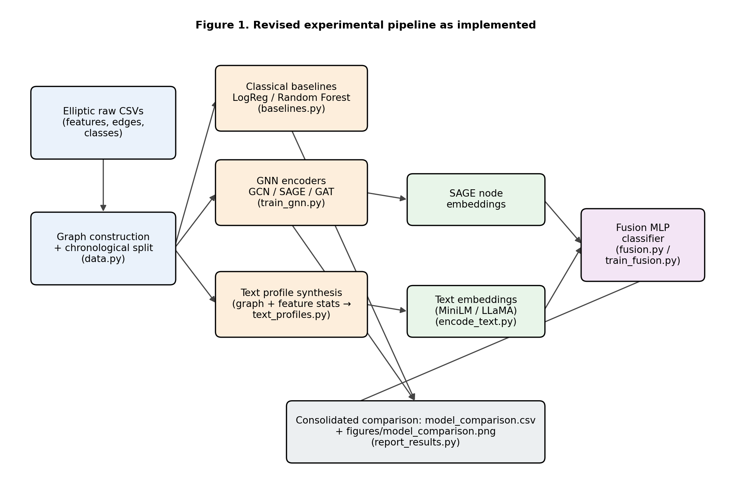
3.3 Timeline and fallback strategies
The table below anchors the remaining work to real calendar weeks following the Assessment 2 submission (20 September 2026). The date of the project's final deliverable was not available at the time of writing this report; the team will insert it once confirmed, and the week-by-week plan below is structured so that it can be compressed or extended around that date without changing its ordering.
Window | Focus | Fallback if blocked
22–28 Sep 2026 (Wk 1) | Re-run LLaMA fusion from a clean checkpoint; reconcile it with the rest of the pipeline so all seven results come from one consistent run. | If LLaMA access/compute is unavailable, report the MiniLM fusion result as primary and clearly label the LLaMA row as a prior, separately-run result.
29 Sep–5 Oct 2026 (Wk 2) | SP8: sample-based explanation generation for nodes the fusion model flags as high-risk, restoring an explainability output. | If generation cost/time is prohibitive across the full test set, restrict it to a fixed small sample (as already done for the LLaMA embedding step) and report it as an illustrative, not exhaustive, capability.
6–12 Oct 2026 (Wk 3) | SP9: implement and test FLAG-style neighbourhood similarity sampling on Elliptic as a secondary validation. | If it does not generalise or does not run in time, report it as a negative/inconclusive finding rather than omitting it — a null result here is still evidence relevant to RQ3.
13–19 Oct 2026 (Wk 4) | Targeted attempt to close the gap to the Random Forest baseline (deeper or regularised GNNs; feeding raw standardised features into the fusion layer alongside embeddings). | If the gap does not close, retain Random Forest as the reported best model and report the gap-closing attempts and their outcomes honestly rather than adjusting the comparison to favour the graph branch.
From 20 Oct 2026 | Consolidate final report and demonstration video; team review pass. | If a team member is unavailable, the pipeline is fully scripted (run_all.py) and reproducible from a clean checkout, so any member can re-run or extend any stage without depending on another's local environment.

Two fallback principles apply across all rows above. First, every sub-problem has an already-working fallback state — the pipeline as it stands today runs end-to-end and produces reportable results, so no single remaining sub-problem being delayed or unsolved puts the whole project at risk of having nothing to report. Second, because the codebase is modular (one file per pipeline stage, orchestrated by a single run_all.py entry point) and version-controlled, any team member can pick up any outstanding sub-problem without needing another member's local setup, which is the project's main mitigation against member unavailability.
Research Progress – Results, Analysis, and Discussion
SP1–SP7 are complete and have been executed end-to-end on the full Elliptic dataset (203,769 nodes, 234,355 edges); SP8 and SP9 are outstanding. Table 1 reports every model's test-set metrics from a single, reproducible run of the pipeline (run_all.py plus the separate LLaMA stage), using the identical chronological split for every row.
Model | Precision | Recall | F1 | ROC-AUC | PR-AUC
Logistic Regression | 0.145 | 0.944 | 0.251 | 0.853 | 0.212
Random Forest | 0.949 | 0.717 | 0.816 | 0.930 | 0.790
GCN | 0.373 | 0.250 | 0.299 | 0.773 | 0.244
GraphSAGE | 0.209 | 0.750 | 0.327 | 0.870 | 0.484
GAT | 0.221 | 0.698 | 0.335 | 0.858 | 0.450
SAGE + MiniLM text fusion | 0.668 | 0.464 | 0.547 | 0.890 | 0.520
SAGE + LLaMA text fusion | 0.695 | 0.708 | 0.702 | 0.874 | 0.767

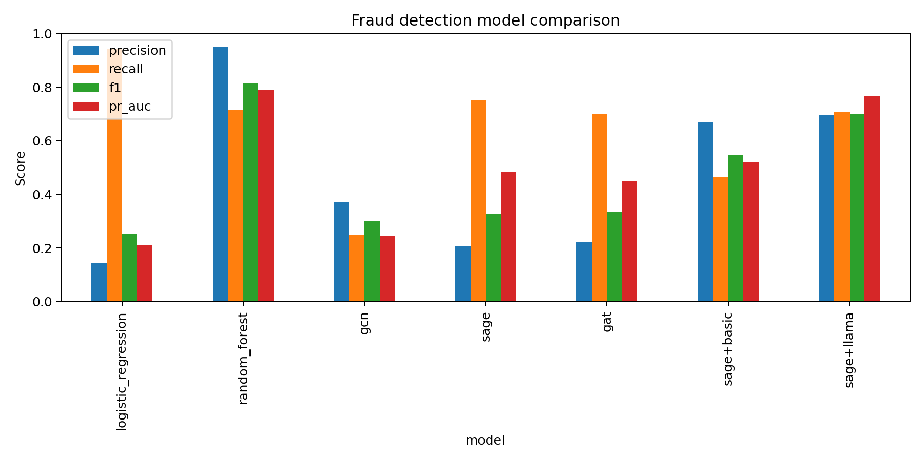
Figure 2. Test-set precision, recall, F1, and PR-AUC across all seven models.
4.1 Deviations from the Assessment 1 plan, their reasons, and their consequences
Deviation 1 – dataset changed from IEEE-CIS to Elliptic. The original plan required constructing graph edges heuristically from shared card, device, or email identifiers in IEEE-CIS, a proxy for relatedness rather than an observed relationship. Elliptic instead provides real, recorded Bitcoin transaction flows as edges, and is the dataset the GNN fraud-detection literature reviewed in Section 2 most consistently benchmarks against (Weber et al., 2019, and the work that follows it). Consequence: this made the graph branch more defensible — GNN performance now reflects real relational structure, not an artefact of the heuristic used to build edges — but it also meant the project could no longer draw directly on IEEE-CIS's richer categorical/textual transaction metadata (merchant category, device and email domain information) that the original TAPE-style design was built around, which forced Deviation 2 below.
Deviation 2 – LLM component changed from per-node explanation generation to embedding fusion. The A1 design called for prompting an LLM to classify each transaction and generate a natural-language explanation, following He et al.'s (2024) TAPE architecture, with that explanation then encoded as a feature. Run at the scale of a full labelled Elliptic split (tens of thousands of labelled nodes, and hundreds of thousands of nodes overall), this requires one LLM generation call per node, which is not feasible within this project's compute and time budget. The implemented pipeline instead synthesises a short factual text profile per node from already-available graph and feature statistics (Deviation 3, below) and encodes it directly, once, with no generation step. Consequence: this is the project's most consequential simplification, and it has a real cost — it drops the explainability output that the explanation-as-feature design was specifically chosen to provide (part of RQ2), and it likely caps how much new information the text branch can contribute, since a profile built from the same underlying features the GNN and Random Forest already see is not obviously carrying new signal in the way a genuinely external description would. The results in Table 1 partially confirm this concern (discussed in 4.2), but the size of the fusion improvement was larger than this reasoning alone would predict, which is itself a finding worth further investigation in the remaining project stages.
Deviation 3 – text profiles synthesised rather than sourced natively. Because Elliptic has no native text and A1's plan assumed IEEE-CIS's categorical metadata would supply it, a new sub-problem (SP4) not in the original decomposition had to be added: generating a natural-language profile per node from in/out-degree and standardised feature-magnitude statistics, with the label explicitly withheld. Consequence: this is a necessary but imperfect substitute for genuine transaction narrative text — it is derived entirely from numbers already present in the tabular features, so it should be read as a text-shaped re-encoding of existing information rather than as new contextual knowledge of the kind LLMs are usually valued for.
Deviation 4 – two classical baselines and three GNN architectures added, beyond A1's single-GNN plan. A1 specified one GNN baseline (GCN or GraphSAGE). The implemented pipeline trains all three of GCN, GraphSAGE, and GAT, plus Logistic Regression and Random Forest. Consequence: this was a deliberate scope addition, not a forced one, made because a single-architecture comparison would not have let the project distinguish “GNNs underperform on Elliptic” from “this one GNN implementation underperforms”; it costs extra training time but has already paid off, since all three GNN architectures show the same qualitative pattern (Section 4.2), which is stronger evidence than any one of them alone.
Deviation 5 (outstanding, not yet attempted) – FLAG-style neighbourhood similarity sampling. A1 proposed this as a secondary validation on IEEE-CIS. It has not been ported to Elliptic yet; the team prioritised getting the core seven-model comparison running correctly and reproducibly first. This is listed as outstanding, not abandoned, in Section 3.3's timeline.
4.2 Results, analysis, and discussion
Random Forest is the strongest model on every metric except recall: precision 0.949, F1 0.816, and PR-AUC 0.790, all well ahead of every graph-based or fusion model. This is not an isolated anomaly of this implementation — it is consistent with Weber et al.'s (2019) original Elliptic benchmark, which likewise found a Random Forest baseline outperforming their GCN baseline on illicit-class F1, and it is the headline finding this stage of the project has to report honestly rather than downplay: on Elliptic specifically, the 166 hand-engineered node features already carry most of the exploitable signal, and a tree ensemble extracts it more effectively than the GNN and fusion models implemented so far.
Logistic Regression sits at the opposite extreme (precision 0.145, recall 0.944): it is a high-sensitivity, low-specificity detector that flags most fraud but with very many false positives, which is of limited practical use on its own but is a useful reference point for how far the more sophisticated models move along the precision/recall trade-off.
The three plain GNNs (GCN F1 0.299, GraphSAGE 0.327, GAT 0.335) all sit below Random Forest on precision and F1 despite reasonable ROC-AUC (0.77–0.87), and all three show the same pattern of comparatively high recall and low precision. Because this pattern holds across three different GNN architectures rather than one, it is more likely attributable to how the graph branch as implemented here — two-layer encoders, class-weighted loss, PR-AUC-based early stopping — trades precision for recall on this dataset, than to a weakness specific to any single architecture. This is the sub-problem Deviation 4 was designed to de-risk, and it has done so: the project can now say “the GNN branch generally underperforms Random Forest here” with more confidence than a single-architecture comparison would allow.
Text fusion is where the clearest positive result lies. Adding MiniLM text embeddings to GraphSAGE raises F1 from 0.327 to 0.547 and PR-AUC from 0.484 to 0.520; replacing MiniLM with the larger LLaMA-3.2-1B encoder raises F1 further to 0.702 and PR-AUC to 0.767 — nearly matching Random Forest's PR-AUC (0.790) and closing most of the precision gap (0.695 vs 0.949). This is genuine partial evidence for RQ2: within the GNN branch specifically, LLM-derived text augmentation produces a large, monotonic improvement as encoder capacity increases, even though the underlying text profile is synthesised rather than natively textual (Deviation 3). It must be reported with two honest qualifications, however. First, the LLaMA fusion result was produced on a controlled, labelled-node sample (as planned in Assessment 1 for compute-feasibility reasons) rather than the full labelled set the other six models use, so it is not perfectly comparable to the rest of Table 1 and is flagged for reconciliation in Section 3.3's Week 1 task. Second, and more importantly for RQ2 as originally framed, even the best fusion result does not yet overtake Random Forest overall — so the project's current, honest answer to “does LLM augmentation help” is: clearly yes, relative to the GNN-only baselines it was added to; not yet, relative to the strongest baseline in the comparison as a whole.
4.3 Status summary
• Complete: chronological-split data pipeline (SP1); classical baselines (SP2); three GNN architectures (SP3); text-profile synthesis (SP4); dual text encoders and fusion classifier with leakage-safe threshold selection (SP5–SP6); consolidated seven-model comparison (SP7).
• Partially complete: LLaMA fusion result exists but on a sampled subset that needs reconciling with the full-split results used for every other model.
• Outstanding: explanation generation / explainability output (SP8); FLAG-style neighbourhood similarity validation (SP9); closing, or fully explaining, the remaining gap to the Random Forest baseline.
Individual Contributions
[TEAM TO COMPLETE — the breakdown below must be filled in accurately by each member before submission; the brief explicitly requires this section to be accurate, and it should not be written on a member's behalf. The task inventory beneath each name is drawn from the repository's actual pipeline stages so it can be allocated/edited to match who actually did what, rather than assumed.]
Prajan Bhattarai
Contribution to date: [TEAM TO COMPLETE]
Planned contribution, remaining stages: [TEAM TO COMPLETE]
Mustafa Ugur Atas
Contribution to date: [TEAM TO COMPLETE]
Planned contribution, remaining stages: [TEAM TO COMPLETE]
Zeki Kose
Contribution to date: [TEAM TO COMPLETE]
Planned contribution, remaining stages: [TEAM TO COMPLETE]
Abhishek Biswal
Contribution to date: [TEAM TO COMPLETE]
Planned contribution, remaining stages: [TEAM TO COMPLETE]
Unassigned task inventory for reference (from the executed pipeline and this report): data pipeline and chronological split (data.py); classical baselines (baselines.py); GNN architectures and training loop (gnn_models.py, train_gnn.py); text-profile synthesis (text_profiles.py); text encoding, both MiniLM and LLaMA (encode_text.py); fusion classifier and leakage-safe evaluation methodology (fusion.py, train_fusion.py); results consolidation (report_results.py); literature review and bibliography; this report's methodology, results analysis, and write-up.
Future Outlook
Four lines of work are expected to occupy the remainder of the project, in the priority order reflected in the Section 3.3 timeline. First, restoring an explainability output is the most direct way to recover value lost in Deviation 2: rather than generating an LLM explanation for every node (infeasible, as explained in Section 4.1), the plan is a sample-based version — generating a rationale only for nodes the fusion classifier flags as high-risk, following the same controlled-sample strategy already used successfully for the LLaMA embedding stage. This is expected to be tractable and to directly address the explainability component of RQ2 that the current pipeline does not yet answer.
Second, the FLAG-style neighbourhood similarity sampling proposed in Assessment 1 as a secondary validation has not yet been ported from its original IEEE-CIS target to Elliptic. Given that the plain GNNs' weakness here shows up as a precision problem across all three architectures rather than as an architecture-specific failure, it is not yet clear whether Elliptic's difficulty for GNNs is primarily a camouflage problem of the kind FLAG's sampling was designed to mitigate, or primarily a matter of the engineered features already containing most of the useful signal (as Section 4.2 argues, consistent with Weber et al., 2019). Running this experiment is the most direct way to distinguish between those two explanations, and is treated as a genuinely open question rather than an assumed positive result.
Third, the remaining gap to the Random Forest baseline needs either closing or explaining more fully. Candidate approaches include feeding raw standardised node features into the fusion layer alongside the learned GraphSAGE embedding (so the fusion model has direct access to the same signal Random Forest uses, rather than only an indirect, GNN-compressed version of it), deeper or regularised GNN encoders, and systematic hyperparameter tuning rather than the fixed defaults used for the results in Table 1. It is treated as a real possibility, not merely a risk to be hedged against, that Random Forest remains the strongest single model through to the final report; if so, the project's contribution is the controlled, reproducible demonstration of exactly where and how much LLM-based text augmentation helps the graph branch specifically, which is itself a defensible and literature-relevant finding (Section 2's research gap targeted fraud-class precision/recall/F1, not merely beating every baseline outright).
Fourth, the LLaMA fusion result currently sits on a sampled subset of labelled nodes rather than the full split used elsewhere in Table 1; reconciling this — either by extending the LLaMA run to the full labelled set if compute allows, or by re-running the MiniLM comparison on the identical sampled subset for a fair like-for-like comparison — is a near-term task that affects how confidently the LLaMA result can be compared to the rest of the table in the final report.
Finally, RQ3 — how well an LLM-augmented approach generalises to unseen or evolving fraud patterns under limited labels — is only partially addressed by the current pipeline. The chronological split already gives every model in Table 1 a genuine test of forward-in-time generalisation, since timesteps 35–49 are never seen during training or model selection, and the fusion models' consistent improvement over GraphSAGE alone on this forward split is itself a small piece of evidence toward RQ3. What is missing is a more direct low-label test: deliberately restricting the amount of labelled training data available to the LLM-augmented model and the GNN-only baseline, and comparing how each degrades, would speak far more directly to the "limited labelled data" framing in RQ3 than the current full-training-set comparison does. This is realistically a stretch goal for the timeline in Section 3.3 rather than a committed deliverable, and will be attempted only once SP8 and SP9 are complete or clearly blocked.
Bibliography
APA 7th edition. [Team: verify DOIs/details against original sources before final submission; apply hanging indent when formatting the final Word document.]
Alghofaili, Y., Albattah, A., & Rassam, M. A. (2020). A financial fraud detection model based on LSTM deep learning technique. Journal of Applied Security Research, 15(4), 498–516.
Ali, A., Abd Razak, S., Othman, S. H., Eisa, T. A. E., Al-Dhaqm, A., Nasser, M., ... & Saif, A. (2022). Financial fraud detection based on machine learning: A systematic literature review. Applied Sciences, 12(19), 9637.
Chen, J. I. Z., & Lai, K. L. (2021). Deep convolution neural network model for credit-card fraud detection and alert. Journal of Artificial Intelligence, 3(2), 101–112.
Cheng, Y., Guo, J., Long, S., Wu, Y., Sun, M., & Zhang, R. (2024). Advanced financial fraud detection using GNN-CL model. In 2024 International Conference on Computers, Information Processing and Advanced Education (CIPAE) (pp. 453–460). IEEE.
Haghighi, V., Soltani, B., Shabani, N., Wu, J., Zhang, Y., Yao, L., Sheng, Q. Z., & Yang, J. (2024). TROPICAL: Transformer-based hypergraph learning for camouflaged fraudster detection. In 2024 IEEE International Conference on Data Mining (ICDM) (pp. 121–130). IEEE. https://doi.org/10.1109/ICDM59182.2024.00019
Hamilton, W. L., Ying, R., & Leskovec, J. (2017). Inductive representation learning on large graphs. In Advances in Neural Information Processing Systems 30 (NeurIPS 2017).
He, X., Bresson, X., Laurent, T., & Hooi, B. (2024). Harnessing explanations: LLM-to-LM interpreter for enhanced text-attributed graph representation learning. In Proceedings of the International Conference on Learning Representations (ICLR 2024).
Kesharwani, A., & Shukla, P. (2024). FFDM-GNN: A financial fraud detection model using graph neural network. In 2024 International Conference on Computing, Sciences and Communications (ICCSC) (pp. 1–6). IEEE.
Kipf, T. N., & Welling, M. (2017). Semi-supervised classification with graph convolutional networks. In Proceedings of the International Conference on Learning Representations (ICLR 2017).
Li, Y., Hu, J., Hooi, B., He, B., & Chen, C. (2025). DGP: A dual-granularity prompting framework for fraud detection with graph-enhanced LLMs. arXiv. https://arxiv.org/abs/2507.21653
Luo, R., Wang, N., & Zhu, X. (2025). Fraud detection and risk assessment of online payment transactions on e-commerce platforms based on LLM and GCN frameworks. arXiv. https://arxiv.org/abs/2509.09928
Meta AI (2024). The Llama 3 herd of models. arXiv. https://arxiv.org/abs/2407.21783
Motie, S., & Raahemi, B. (2024). Financial fraud detection using graph neural networks: A systematic review. Expert Systems with Applications, 240, 122156.
Reimers, N., & Gurevych, I. (2019). Sentence-BERT: Sentence embeddings using Siamese BERT-networks. In Proceedings of the 2019 Conference on Empirical Methods in Natural Language Processing (EMNLP-IJCNLP).
Veličković, P., Cucurull, G., Casanova, A., Romero, A., Liò, P., & Bengio, Y. (2018). Graph attention networks. In Proceedings of the International Conference on Learning Representations (ICLR 2018).
Weber, M., Domeniconi, G., Chen, J., Weidele, D. K. I., Bellei, C., Robinson, T., & Leiserson, C. E. (2019). Anti-money laundering in bitcoin: Experimenting with graph convolutional networks for financial forensics. arXiv. https://arxiv.org/abs/1908.02591
Yang, C., Liu, H., Wang, D., Zhang, Z., Yang, C., & Shi, C. (2025). FLAG: Fraud detection with LLM-enhanced graph neural network. In Proceedings of the 31st ACM SIGKDD Conference on Knowledge Discovery and Data Mining (KDD '25).

